Salesforce Associate Reviewer
Salesforce Associate Reviewer

1. Get Cloudy Consulting wants to evaluate a new feature that requires a specific license before purchasing. Which environment should be used?*
1/1
A. Scratch org
B. Developer sandbox
C. Developer org

2. Get Cloudy Consulting's growing marketing team is on a custom profile named Marketing Team. The team currently has Read access to leads and opportunities- Two marketing managers need Edit access on leads.
What should the Salesforce associate do to grant them the access they need?
*
1/1
A. Create a permission set that grants Edit access to leads and assign it to the marketing team.
B. Create a new profile that grants Edit access to leads and assign it to the marketing managers.
C. Create a permission set that grants Edit access to leads and assign it to the marketing managers.

3. A Salesforce associate wants to filter a Lead report by a secondary industry field.
Who would the associate typically work with to get a new field added in their Salesforce org?
*
1/1
A. Salesforce Technical Architect
B. Salesforce Administrator
C. Salesforce Developer

4. Which Salesforce role produces data-driven solutions by eliciting, documenting, and examining requirements around organizational challenges?
*
1/1
A. Platform Developer
B. Business Analyst
C. User Experience Designer

5. What is the maximum number of rows will display?
*
1/1
A. 3, 000
B. 2, 000
C. 5, 000

6. What should the account owner at Get Cloudy Consulting use to learn the sum of the amount for each opportunity?
*
1/1
A. A Roll-Up Summary field
B. The Opportunity related list
C. A custom report type

7. Get Cloudy Consulting encourages end users to update their own settings.
How can an end user access their personal settings?
*
1/1
A. Click the question mark icon in the header, then create a Case.
B. Click the gear, con in the header, then click Setup.
C. Click the profile icon in the header, then click Settings.

8. Get Cloudy Consulting requires a value in the Status field every time a record is created or edited.
What should they do to enforce this?
*
1/1
A. Make the field required in Object Manager.
B. Make the field required with a validation rule.
C. Make the field required in organization-wide defaults.

9. Get Cloudy Consulting' dashboard shows all of the company's key performance indicators (KPls) in one view. The company's Salesforce associate is asked to add functionality that allows the dashboard to show all the same KPls for each of the regions.
How should the associate add this functionality?
*
1/1
A. Create new dashboards for each region.
B. Add a Region filter to the dashboard.
C. Use an analytics package from the AppExchange.

10. A sales manager requests a report that shows total opportunity amounts grouped by:
* Small opportunities --- Amount is less than $50,000.
* Medium opportunities --- Amount is between $50,000 and 5100,000.
* Large opportunities --- Amount is more than $100,000.
How should the Salesforce associate create a field to show the amount as described above?
*
1/1
A. Create a bucket field off of Amount
B. Create a custom field in Setup.
C. Create a formula field off of Amount.

11. How should a Salesforce associate ensure a dashboard has the most current data?
*
1/1
A. By refreshing the browser
B. By clicking refresh
C. By opening the dashboard

12. A Salesforce associate wants to refresh a report and email it to an executive team each week.
Which functionality of Salesforce Reports should the associate use?
*
1/1
A. Refresh
B. Notifications
C. Subscriptions

13. Two users in the same opportunity record are seeing different fields. What is the reason for this?
*
1/1
A. The missing fields are marked as hidden in Object Manager.
B. The users are assigned different profiles and page layouts.
C. The users have been configured with different Locales.

14. A Salesforce associate deletes an Account of a company that recently went out of business.
Which other related records are automatically deleted?
*
1/1
A. Any related leads
B. Any related cases
C. Any related opportunities

15. Which tool creates a visual representation of objects and their relationships?
*
1/1
A. App Launcher
B. Object Manager
C. Schema Builder

16. Get Cloudy Consulting (GCC) has recently been onboarded as a Salesforce customer. GCC wants to enroll its in-house IT administration team in a Salesforce instructor-led training workshop.
Which resource provides virtual and in-person learning that should help the team accelerate their Salesforce knowledge?
*
1/1
A. Trailhead Community
B. Salesforce Help
C. Trailhead Academy

17. Which sharing type shares a single, common infrastructure and code base?*
1/1
A. Metadata
B. Multitenant
C. Trust

18. How can a user see only contacts from a specific city on the 'New This Week' list view without changing what other users see?*
1/1
A. Change the permissions so they can only see records from the specific city.
B. Clone the list view with a new name, and filter by the specific city.
C. Build a private report for contacts that is filtered by the specific city.

19. Refer to the screenshot that shows the Home page.
A Salesforce Associate wants to reorder items in their instance so the Reports tab appears immediately after Home.
What should the associate do to customize the items on the navigation bar?
*
1/1
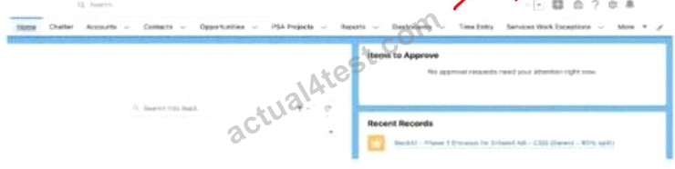
A. Select the personalization button (pencil icon), then click and drag the item name up or down to adjust its location.
B. Use the downward arrow next to each item name, then select Move to move the item left or right.
C. Click the Setup gear icon at the top right of the page, then select User Interface and then Tabs.

20. Salesforce Associate received a promotion and needs Edit access to fields on Opportunity records across the organization.
Which user setting need updating to allow Edit access?
*
1/1
A. Queue
B. Permission Set
C. Public Group

21. When a Sales Rep needs to give an additional discount for an Opportunity. A Manager needs to review and authorize the discount request.
What should be used to lock the record before a decision is made?
*
1/1
A. Validation Rule
B. Approval Process
C. Page Layout

22. A nonprofit organization wants to help ensure residents in their area receive health checkups. The nonprofit also wants to ensure resident tracking history and all data are stored in a way that complies with local privacy laws.
Which Salesforce Cloud solution should help meet these needs?
*
1/1
A. Health Cloud
B. Service Cloud
C. Nonprofit Cloud

23. Get Cloudy Consulting is rolling out Salesforce to its organization. New users may have different access requirements based on department.
What should be recommended to allow new users the correct access based on their department's requirements?
*
1/1
A. Role Hierarchy
B. Individual Profiles
C. Permission Sets

24. Get Cloudy Consulting (GCC) is experiencing significant performance degradation.
What should GCC do to quickly verify if a performance incident has been reported on its instance of Salesforce?
*
1/1
A. Ask a question on the Trailblazer Community.
B. Check System Status on the Trust site.
C. Open a case with Salesforce Support.

25. A Salesforce Associate at Get Cloudy Consulting is working with a user to view multiple records and their related records on the same screen. Currently, the user uses multiple browser tabs.
Which app should the Associate recommend for the user to view multiple records and their related records on one screen?
*
1/1
A. Salesforce Lightning Page
B. Salesforce Lightning Console
C. Salesforce Dashboard

26. A Manager is creating a dashboard for their team and wants each team member to receive a copy of the dashboard results by email each week.
What should the team members do to ensure they receive their weekly results?
*
1/1
A. Like the dashboard
B. Subscribe to the dashboard
C. Follow the dashboard

27. A Salesforce Associate wants a visual summary of Opportunities in a list view. The Associate would like to summarize, filter, and move opportunities along the pipeline.
What should they do to meet this requirement?
*
1/1
A. Create an Opportunity Summary Report.
B. Create an Opportunity List View.
C. Create an Opportunities Kanban View.

28. A Salesforce Associate wants to add a new related list of Cases to Account.
Where should the Associate go to add the related list to Account?
*
1/1
A. Account Record page
B. Page Layout
C. Case Record page

29. Get Cloudy Consulting currently stores information about its Customers and Partners in the Account object. There are few details specific to Partners that are not applicable to Customers.
What is the recommended way to display only the information application to each group?
*
1/1
A. Use Account for Customers and create a custom object for Partners.
B. Create record types on Account called Partner and Customer.
C. Create custom object called Partner and Customer.

30. Get Cloudy Consulting gets 90% of its business from trade shows. Sales reps create many lead records during these events, but they often forget to change the Lead Source field to 'Trade Show'.
What should help the Sales Reps when they create these Lead records?
*
1/1
A. Make an Assignment Rule name 'Trade Show' to only assign Leads to Sales Reps.
B. Format a Validation Rule requiring the Lead Source field to equal 'Trade Show'.
C. Change the default value of the Lead Source field from 'Web' to 'Trade Show'.

31. A Salesforce Associate has received a request to create new users for a group of new employees.
Where can the Associate check the number of licenses available to be assigned to the new employees?
*
1/1
A. Salesforce Help
B. Company Information
C. User Management Settings

32. Refer to the image below:
A Salesforce Associate reviews a report that shows more information than they need. The Associate see individual records but only wants to see the Record Count.
Which switches should the Associate toggle to only show the Record Count?
*
1/1
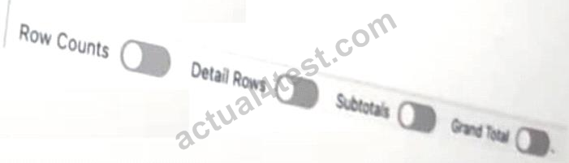
A. Row Counts and Grand Total

B. Subtotal and Detail Rows
C. Grand Total and Subtotals

33. A Salesforce Associate is asked to share records about a carpool program with users.
Which type of group should the Associate create?
*
1/1
A. Private Group(s)
B. Public Group(s)
C. Queue

34. A Marketing Manager wants to make the Reason Lost field required on the Opportunity when the stage is changed to 'Closed Lost'.
What should the Salesforce Associate do to enforce this requirement?
*
1/1
A. Make the field required on the page layout.
B. Create a Validation Rule on the Opportunity object.
C. Make the filed universally required.

35. An organization wants to implement Salesforce into its business model. The requirements include:
• Operations management
• Program management
• Grantmaking
• Fundraising
• Marketing
• Engagement
Which cloud is preconfigured to handle all of these requirements?*
1/1
A. Experience
B. Analytics
C. Nonprofit

36. A Salesforce standard profile end user is looking for specific information on an Opportunity record page. They are overwhelmed by the required scrolling to see the page.
What should the user do to simplify the page to see only what they want?*
1/1
A. Collapse detail sections
B. Remove activities
C. Change page-layout assignments

37. Get Cloudy Consulting (GCC) currently supports its customers via calls and emails. GCC wants to meet the needs of digitally savvy customers by offering support via web chat as well as SMS, Facebook Messenger, and whatsApp.
Which Salesforce product should meet this need?*
1/1
A. Service Cloud
B. Experience Cloud
C. Mulesoft

38. Get Cloudy Consulting (GCC) wants to ensure the Annual Revenue field is a positive amount and does not exceed $100.
What should GCC use to ensure to opportunities meet these standards?
*
1/1
- Validation Rules
- Assignment Rules
- Default Values

39. Which relationship type exists between Accounts and Contacts?
*
Master-detail
Self
Lookup

40. An employee at Get Consulting recently changed their name and received a new username.
Where should these changes be updated?
*
1/1
- Contact Record page
- User Record page from Setup
- User profile page

41. A Salesforce associate wants to learn more about converting Leads to Contacts. They enjoy learning in an asynchronous, gamified way.
Which resource should they use?
*
1/1
- Salesforce Help
- Trailblazer Community
- Trailhead

42. A Salesforce associate is working from a custom Contact list view and noticed key information is missing.
What should they do to add the missing information?
*
- Edit sharing settings
- Select Fields to Display
- Edit list filters

43. The salesforce account executive for Get Cloudy Consulting’s (GCC) advises the company to use United Clouds to assist with its transition to using Salesforce as its CRM. GCC also plans to add an app in salesforce from Connected Mail.
What is the role of each of these companies?
- Get Cloudy Consulting - Customer Connected Mail - Independent Software Vendor (ISV) United Clouds - Partner
- Get Cloudy Consulting - Customer Connected Mail - Consultant - United Clouds - Partner
- Get Cloudy Consulting - Customer Connected Mail - Product United Clouds - Partner Independent Software Vendor (ISV)

44. Get Cloudy Consulting (GCC) wants to customize its Sales application’s Home tab with additional components. Outside of the org, where should GCC' Salesforce associate go to collaborate with others on solutions that might resonate with GCC users?
- Explore documents In Help and Training.
- Ask a question In a Trailblazer Community Group.
- Search for modules in Trailhead.

45. A marketing manager wants to make the Reason Lost field required on the opportunity when the stage is changed to Closed Lost.
What should the salesforce associate do to enforce this requirement?
- Make the field required on the page layout.
- Create a validation rule on the Opportunity object.
- Make the field universally required.

46. A Salesforce associate is creating a report that needs to show changes uin a value over a series of point in time.
Which type of chart should the associate add to this report to help visualize these changes?
- Line
- Scatter
- Donut

47. A Salesforce associate wants to learn more about an app to see if it would be a good fit for a business need, but they are not a system administrator.
Where can they learn more about the app?
- AppExchange
- Trailhead
- Global Search

48. Get Cloudy Consulting is rolling out Salesforce to its organization.
What should be used to allow additional field-level access to individual employees based on the their job duties?
- Individual profiles
- Permission sets
- Role Hierarchy

49. Get Cloudy Consulting wants to confirm the data type of the Account Sources field on Account object.
Which editing the Account, the Account Sources field has several predefined values that can be selected.
Which type of field is Account Source?
- Picklist
- Formula
- Text Area

50. A Salesforce associate is asked to add a new employee record to their client. Get Cloudy Consulting.
To which object should they add this record?
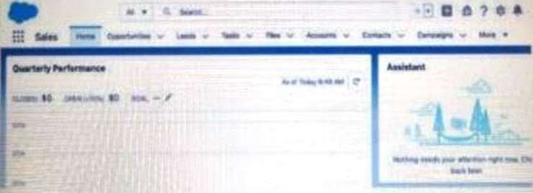
- Accounts
- Leads
- Contacts

51. To which Team should a Salesforce associate be added to gain access to an Account and its related opportunities?
- Opportunity Team
- Lead Team
- Account Team

52. A Salesforce associate wants to locate a record within the custom object called 'Shipment'.
What is the most efficient way to find a record within this object?

Global Search
App Launcher
Object Manager

No correct answers

53. Get Cloudy Consulting (GCC) wants the ability to:
* Send a predefined sequence of scheduled messages to prospective customers.
* Track messages that get the best open and response rates.
* Send customized messages to existing customers information them for new products and discounts.
Which Salesforce cloud solution allows GCC to meet these requirements?

- Sales Cloud
- Marketing Cloud
- Service Cloud
54. Bonus*
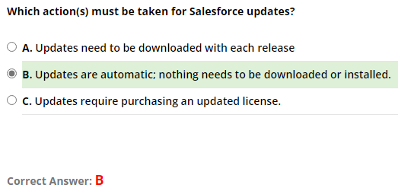
B
55. Bonus*
